**OVER 5 TONNES OF SMUGGLED GLASS EELS SEIZED IN EUROPE THIS YEAR**

*06 November 2019*

*Press Release*

[Print](https://www.europol.europa.eu/print/newsroom/news/over-5-tonnes-of-smuggled-glass-eels-seized-in-europe-year)[PDF](https://www.europol.europa.eu/printpdf/newsroom/news/over-5-tonnes-of-smuggled-glass-eels-seized-in-europe-year)

* [E-mail](mailto:?subject=Over%205%20tonnes%20of%20smuggled%20glass%20eels%20seized%20in%20Europe%20this%20year%20%7C%20Europol&body=https%3A%2F%2Fwww.europol.europa.eu%2Fnewsroom%2Fnews%2Fover-5-tonnes-of-smuggled-glass-eels-seized-in-europe-year)
* [Facebook](http://www.facebook.com/share.php?u=https%3A%2F%2Fwww.europol.europa.eu%2Fnewsroom%2Fnews%2Fover-5-tonnes-of-smuggled-glass-eels-seized-in-europe-year&t=Over%205%20tonnes%20of%20smuggled%20glass%20eels%20seized%20in%20Europe%20this%20year%20%7C%20Europol)
* [Twitter](https://twitter.com/intent/tweet?url=https%3A%2F%2Fwww.europol.europa.eu%2Fnewsroom%2Fnews%2Fover-5-tonnes-of-smuggled-glass-eels-seized-in-europe-year&text=Over%205%20tonnes%20of%20smuggled%20glass%20eels%20seized%20in%20Europe%20this%20year%20%7C%20Europol)
* [LinkedIn](http://www.linkedin.com/shareArticle?mini=true&url=https%3A%2F%2Fwww.europol.europa.eu%2Fnewsroom%2Fnews%2Fover-5-tonnes-of-smuggled-glass-eels-seized-in-europe-year&title=Over%205%20tonnes%20of%20smuggled%20glass%20eels%20seized%20in%20Europe%20this%20year%20%7C%20Europol&ro=false&summary=&source=)

THIS NEWS/PRESS RELEASE IS ABOUT [COCAINE AND HEROIN](https://www.europol.europa.eu/crime-areas-and-trends/crime-areas/drug-trafficking/cocaine-and-heroin)

[*View all crime areas*](https://www.europol.europa.eu/crime-areas-and-trends/crime-areas)

[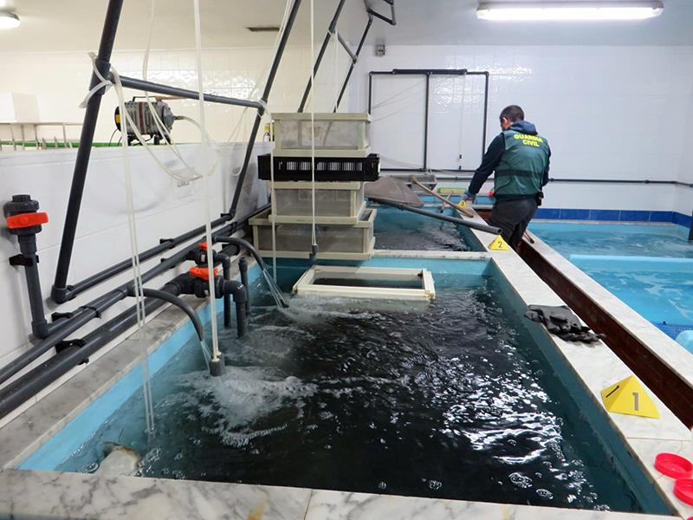](https://www.europol.europa.eu/sites/default/files/styles/europol_extra_large/public/images/1_13.jpg?itok=G1Zk0w27)

[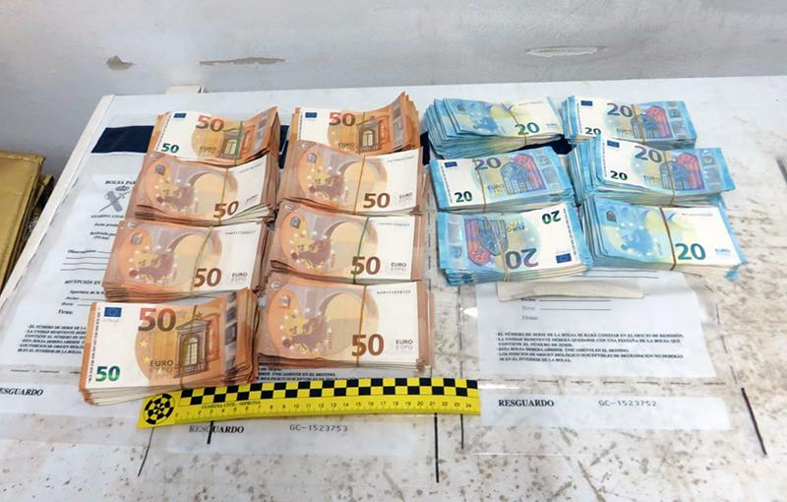](https://www.europol.europa.eu/sites/default/files/styles/europol_extra_large/public/images/2_7.jpg?itok=s7NHP79V)

[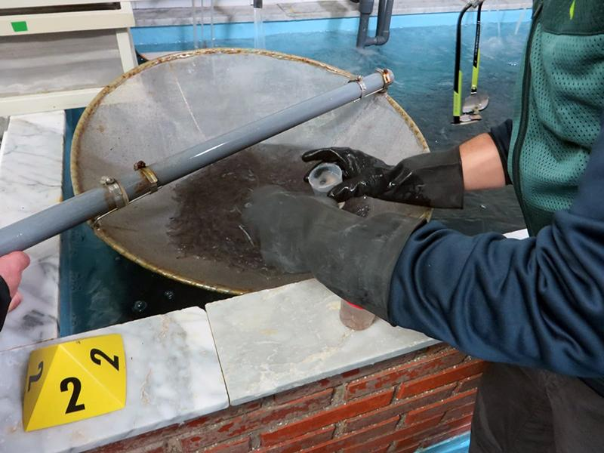](https://www.europol.europa.eu/sites/default/files/styles/europol_extra_large/public/images/3_7.jpg?itok=fD9HSTRP)

During the most recent fishing season (2018-19), European law enforcement was able to seize 5 789 kg of smuggled glass eels with an estimated value of € 2 000 per kilo. In total 154 suspected smugglers were arrested and all seized eels were reintroduced into their natural habitat, which is crucial for the survival of the species. This year’s Operation Lake, initiated by Europol and together with Eurojust, INTERPOL and the EU Wildlife / CITES Enforcement Group has seen the involvement of 10 countries in the 448 operations across Europe: Albania, Bulgaria, Hungary, Czechia, France, Germany, North Macedonia, Portugal, Spain and Switzerland.

From October 2018 until April 2019 and under the umbrella of the European Union Action Plan against wildlife trafficking, a wide range of activities have been carried out in order uncover every possible illicit practice linked to the fishing of glass eels, such as checking luggage and cargo at ports and airports with international destinations. Law enforcement also conducted cross-border investigations into European-based Asian criminal networks. Operation Lake aims to combat trafficking of endangered species in the EU and to dismantle violent organised crime groups involved in associated illegal activities, such as [environmental crime](https://www.europol.europa.eu/crime-areas-and-trends/crime-areas/environmental-crime), smuggling, [money laundering](https://www.europol.europa.eu/crime-areas-and-trends/crime-areas/economic-crime/money-laundering), tax evasion and document counterfeiting.

**38 ARRESTS AND MORE THAN 700 KG OF GLASS EELS SAVED IN OPERATION FAME**

Operation Fame was 2019’s flagship environmental operation. In early 2019, three operational meetings were held (one in Spain and two at Europol’s headquarters) to coordinate details for different actions in Czechia, France, Germany, Portugal, Spain and Switzerland which resulted in the arrest of 43 individuals alongside the seizure of 737 kg of glass eels. The fish were put in plastic bags and suitcases and sent to Asia by plane. The criminals also camouflaged the glass eels among other cargo commodities (usually fresh products such as fish and meat):

* Czech customs officials arrested two people and seized 40 kg of glass eels.
* German customs officials arrested three individuals and seized 176 kg of glass eels.
* French customs and the French Central Office against Environmental and Public Health Crime arrested ten people involved in the smuggling of this species and seized 716 kg of glass eels.
* The Portuguese Food Safety and Economic Authority, the Portuguese National Republican Guard and the Portuguese Maritime Police carried out five arrests.
* The Spanish Civil Guard (Guardia Civil) under the Europol’s coordination arrested 16 individuals from four different organised crime groups. One of the rings, based in the north of Spain, brought glass eels from France to Spain and then sent them by taxi to Portugal. Once in Portugal, the criminals put the eels into suitcases, ready to export them by plane. Another crime organisation, based in Madrid, shipped higher quantities of glass eels declaring them as other types of fish, seafood and sending them later by air cargo. The seized species would be worth €600 000. Spanish authorities estimate that the four criminal organisations under investigation may have made more than €6 million a year from the illegal operation.
* Swiss authorities arrested seven suspects and seized 78 kg of glass eels.